Ingrese al siguiente link

[https://call.lifesizecloud.com/download](https://nam02.safelinks.protection.outlook.com/?url=https%3A%2F%2Fcall.lifesizecloud.com%2Fdownload&data=02%7C01%7Capoyostreaming%40cendoj.ramajudicial.gov.co%7C6a77c6a82fa44892694208d7e08ff71c%7C622cba9880f841f38df58eb99901598b%7C0%7C0%7C637224781241516909&sdata=03axkMliEBJmRUtk8ie%2BUvFyjM3tbwDVXc3sWG16TSc%3D&reserved=0)

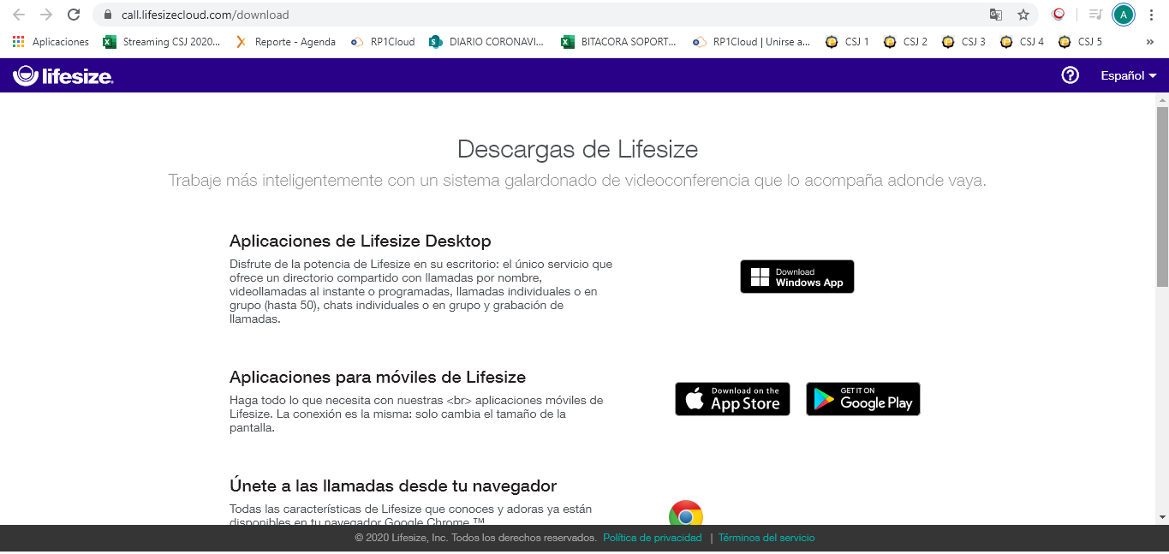

Descargue la aplicación según su sistema operativo

