|  |  |  |  |  |  |  |
| --- | --- | --- | --- | --- | --- | --- |
| **2019-0102** | ORDINARIO  LABORAL | LUIS EDUARDO  ORDOÑEZ CARMONA | CALZADO CRISTIN Y OTROS | 22 JULIO 2019 | 29 JULIO 2019 | EXCEPCIONES  DE MERITO |

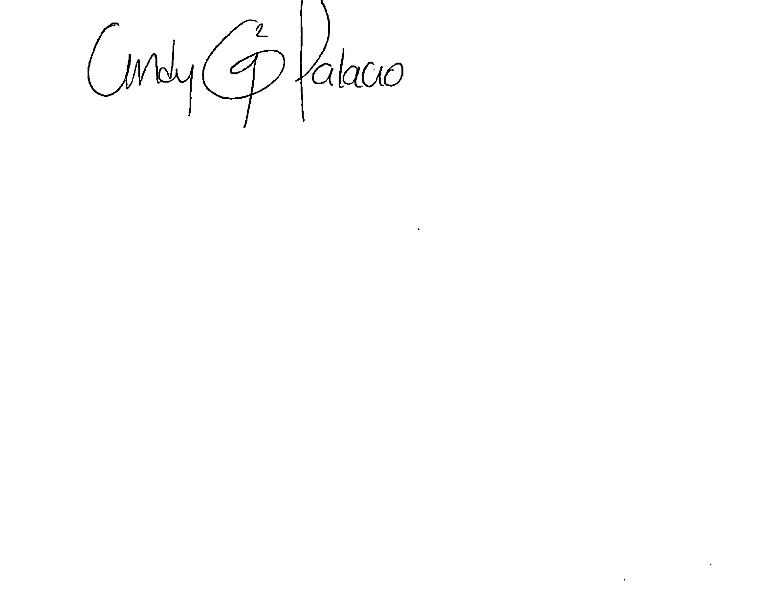

**____________________________________**

**CINDY GABRIELA PALACIO GALINDO**

**SECRETARIA AD-HOC**