|  |  |  |  |  |  |  |
| --- | --- | --- | --- | --- | --- | --- |
| **2018-0183** | EJECUTIVO | BANCOLOMBIA S.A. | ELKIN JAIR ALVAREZ SUAREZ | 16 JULIO 2019 | 19 JULIO 2019 | LIQUIDACION DE  CREDITO |
| **2018-0139** | ORDINARIO  LABORAL | JUVENAL  PINZON RIVERA | PRODUCTOS QUIMICOS PANAMERICANOS | 16 JULIO 2019 | 19 JULIO 2019 | EXCEPCIONES  PREVIAS |

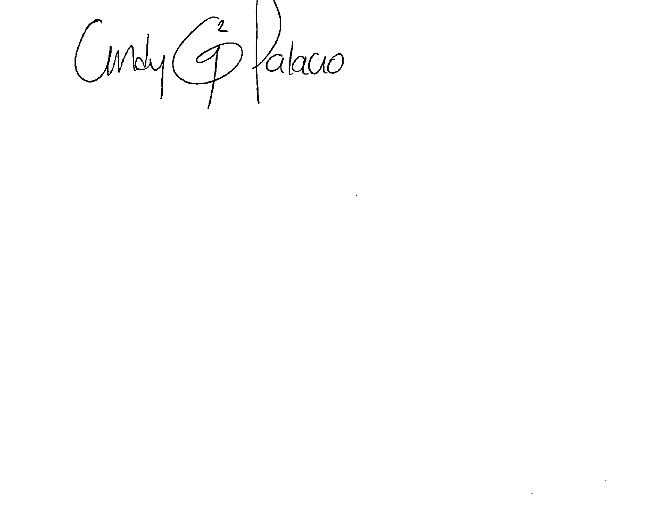

**____________________________________**

**CINDY GABRIELA PALACIO GALINDO**

**SECRETARIA AD-HOC**